Restaurant Management Application Design Report

Coursework: Design Exercises (CW1)

Name: Okyanus

Student ID: 10927274

Module: COMP2000

Date: 25/09/2025

GitHub Repo Link: https://github.com/Plymouth-COMP2000/design-exercises-OkyanusAlbas

Exercise 1 Context of Use & Intended Users

Context of Use and Intended Users

Intended Users

Staff: Managers, Waitstaff, Supervisors

Goals: Maintain accurate menu; manage and confirm/cancel reservations; respond to new bookings; ensure smooth operations.

Guests: Customers

Goals: Browse menu price, images book, edit, or cancel tables.

Contexts of Use

Physical/Environmental

Staff: Busy, noisy setting; quick, one-hand interactions while multitasking.

Guests: At home or mobile; casual browsing or quick booking.

Social/Organizational

Staff: Collaborative, time-pressured; shared edits and conflict handling needed.

Guests: Individual or group decisions; expect clear confirmations.

Technical

Platform: Mobile-responsive app.

Data/APIs: Secure REST API with roles.

Storage: Local SQLite syncs with server.

Notifications: Push/local, user controlled.

Security: Role-based access, offline-safe storage.

Key Tasks

Staff:

Add/edit/delete menu items; mark unavailable.

View/filter/cancel reservations.

Receive and act on real-time alerts.

Guests:

Browse/search menu.

Create, edit, or cancel reservations.

Get notifications on status changes.

Constraints & Usability

Role-based access control (staff vs guest).

Offline-first operation with sync.

Fast UI, image caching.

Customizable notifications.

Accessibility: large taps, high contrast.

Locale-ready (currency, date).

Privacy: minimal PII, secure storage, consented notifications.

Exercise 2: 20 marks

Neutral

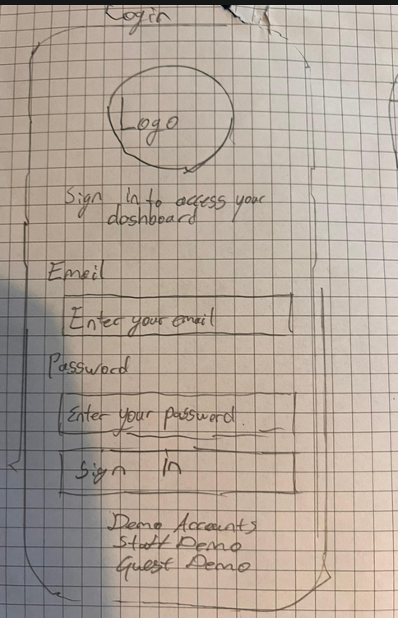

Main Login & Register Pages

Screen: Simple login with email + password also Register with password confirmation by writing it twice

Option: Role is determined by after login (Staff vs Guest) role-based privileges.

HCI Principle: Visibility of system status show error messages, “loading…” indicators.

Guest Side

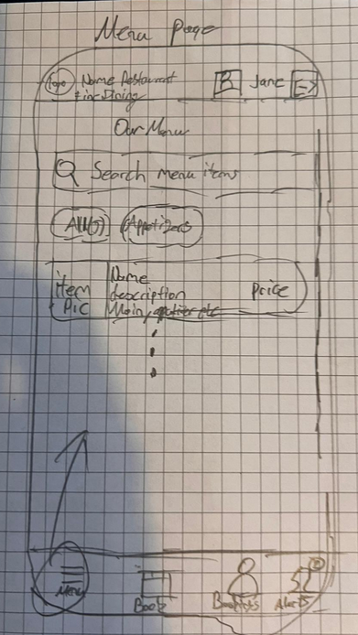

Home/Menu Screen

Top: Restaurant logo, navigation bar.

Middle: Scrollable list of menu items -> each item has image, name, price.

Bottom: “Make a Reservation” button.

HCI Principle: Recognition over recall (visual images of food, no hidden menus).

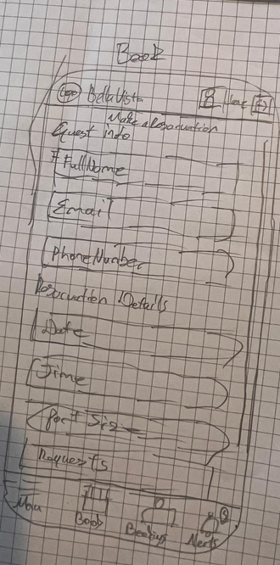

1. Reservation Form Screen

Input fields: Date picker, Time picker, Number of guests, Notes.

Confirm button.

Feedback: “Reservation Confirmed” pop-up.

HCI Principle: Error prevention (restrict invalid dates/times).

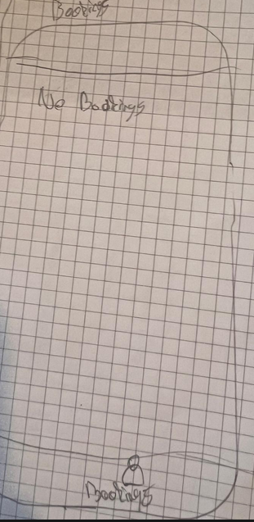

My Reservations Screen

List of upcoming reservations with edit/cancel options.

HCI Principle: User control and freedom (easy cancellation/undo).

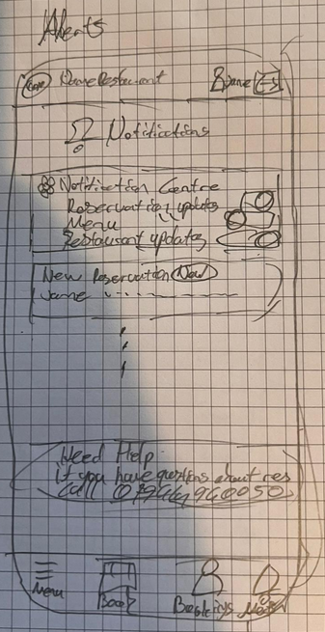

Notification Preferences Screen

Toggles for: Reservation confirmation, Reservation changes, Promotions.

HCI Principle: Flexibility and efficiency.

Staff Side

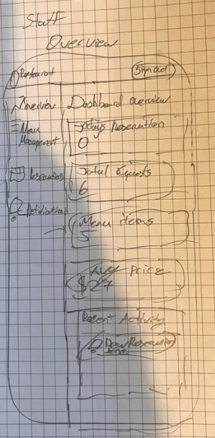

Dashboard/Overview Screen

Two buttons: “Menu Management” | “Reservations.”

Notification bell icon shows new reservations.

HCI Principle: Consistency and standards (clear icons).

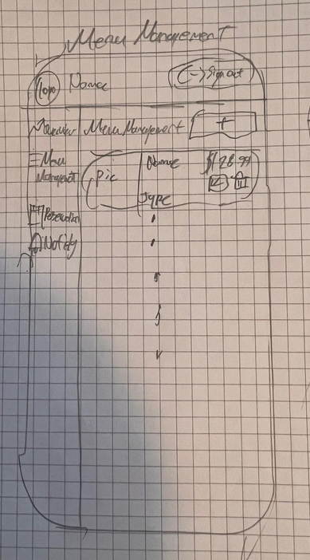

Menu Management Screen

List of current menu items.

Buttons: Add | Edit | Delete (with confirmation prompt).

HCI Principle: Error prevention (confirmation before delete).

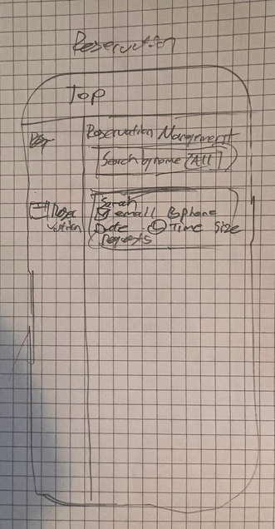

Reservations Screen

List of upcoming reservations with customer name, time, party size.

Options: Cancel reservation, View details.

HCI Principle: Visibility (clear status of each reservation).

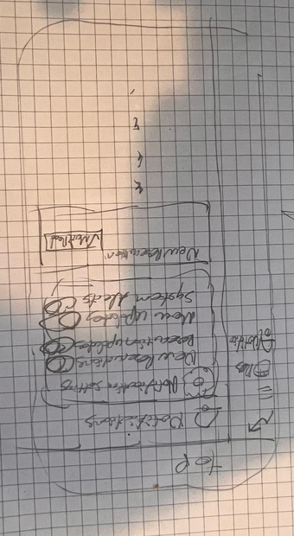

Notification Preferences Screen

Toggles for: Reservation confirmation, Reservation changes, Promotions.

HCI Principle: Flexibility and efficiency.

Story Board

|  |  |  |  |
| --- | --- | --- | --- |
| **Role / Goal** | **Step** | **Screen / Action** | **System Response** |
| **Staff**  **Manage Menu** | 1 | Staff logs in via the **Staff Portal**. | System validates credentials and shows **Staff Dashboard**. |
|  | 2 | Staff selects **“Menu Management.”** | System displays list of menu items. |
|  | 3 | Staff clicks **“Add New Item.”** | System opens a simple form (Name, Price, Upload Image). |
|  | 4 | Staff fills details and clicks **“Save.”** | New item stored in database; menu list refreshed. |
|  | 5 | A new reservation is made. | System sends a simple **popup notification** to staff. |
| **Customer Browse Menu** | 1 | Guest opens mobile app (Guest Mode). | Home screen shows categories (Starters, Mains, Desserts). |
|  | 2 | Guest taps a **category.** | Menu items appear (Name, Price, Image). |
|  | 3 | Guest taps an **item.** | Enlarged image, description, and price displayed. |
| **Customer Make/Edit/Cancel Reservation** | 1 | Guest taps **“Reserve a Table.”** | Reservation form appears (Date, Time, Guests, Notes). |
|  | 2 | Guest submits form. | System validates, saves, and confirms booking. |
|  | 3 | Staff receives notification. | – |
|  | 4 | Guest receives confirmation. | Reservation marked **Pending/Confirmed**. |
|  | 5 | Guest opens **“My Reservations.”** | Shows bookings with status (Confirmed, Pending, Cancelled). |
|  | 6 | Guest edits or cancels booking. | System updates record and notify staff. |
|  | 7 | Staff updates status. | Guest receives status update notification. |

Exercise 3: 30 marks

Formative Usability Evaluation Summary

Purpose

To assess the usability of the low-fidelity prototype of the restaurant management app, identify issues, gauge satisfaction, and collect feedback before high fidelity development.

Method

Think Aloud Usability Testing Formative:  
Participants completed realistic tasks while verbalizing thoughts. Observations captured usability problems, confusion points, and navigation challenges.

Participants

|  |  |  |  |
| --- | --- | --- | --- |
| User | Role | Background | Device Familiarity |
| P1(George) | Guest User | Regular Restaurant customer who books tables for dates | High (mobile apps daily) |
| P2(Jamie) | Staff User | Restaurant waiter responsible for handling reservations and updating menus | High (uses POS systems and internal apps also is ) |

Test Setup

Prototype: Low fidelity paper wireframes

Location: Library (in-person)

Recording: Notes only

Duration: 10 min/session

Tasks

Guest: Log in, browse menu, Make/Edit/Cancel reservation, manage notifications  
Staff: Log in, Add/Edit menu item, View/Cancel reservation, Check notifications

Findings

|  |  |  |  |
| --- | --- | --- | --- |
| Task | Observation | Severity | Recommendation |
| Browse Menu | Missing category filters | Minor | Add filters |
| Make/Edit/Cancel Reservation | “My Reservations” hard to locate | Major | Add direct access |
| My Reservation view | “Reservation screen showed no reservations as it wasn’t included in the drawings” | Major | Add reservation in high fidelity |
| Notifications | Labels unclear | Minor | Add short descriptions |
| Overall | Poorly Drawn | Major | Make High Fidelity Understandable model where it represents the overall idea of the final version |

User Feedback Summary

Test Participants

P1 (George): Wanted clearer better high-quality design and better notifications.

P2 (Jamey): Needed simpler reservation controls for staff.

Key Recommendations

Simplify navigation and add direct links to key actions.

Provide clear confirmation messages and visible progress indicators.

Use intuitive icons paired with text labels.

Clarify notification settings and options.

Refine the prototype based on this feedback before the next testing phase.

Conclusion  
User testing highlighted issues with navigation and visibility but confirmed that the system’s overall concept is relevant and valuable. Insights from this session will directly inform design improvements ahead of the next development phase.

Evidence

George

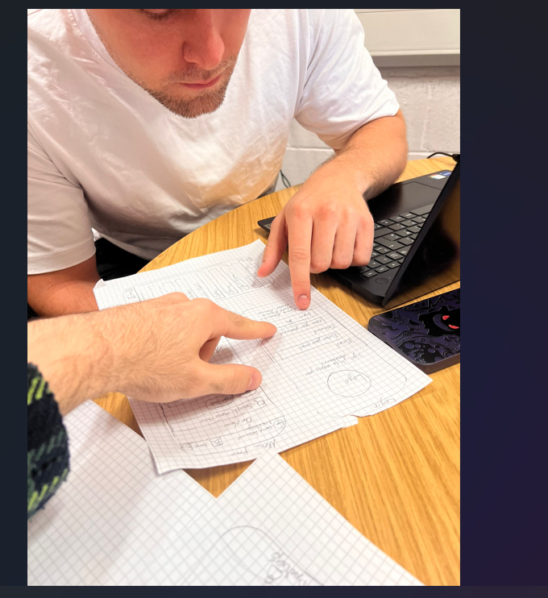

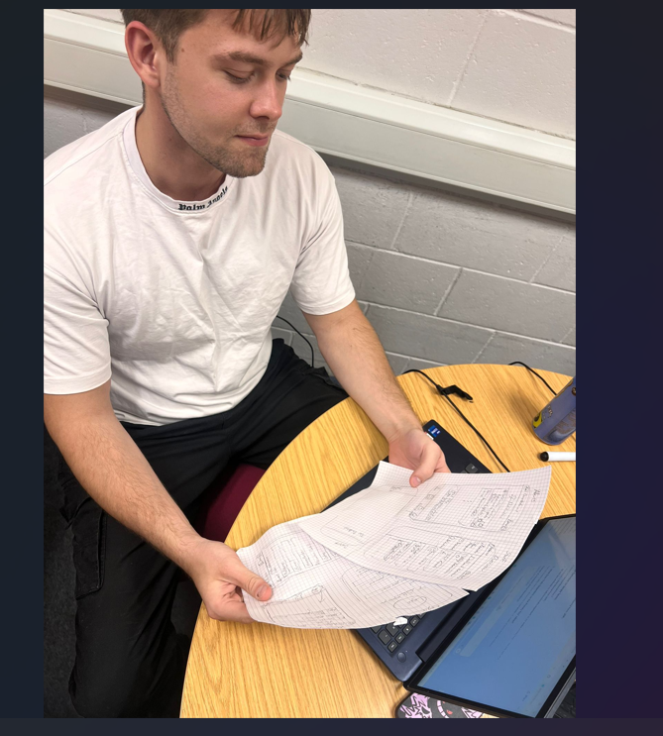

Consent Form

# USER Research Consent Form

Thank you for taking part in our research.

This consent form will help you to understand the purposes of our research. It also outlines how we will use the data that results from your participation.

## Information

### Why we are we doing research?

|  |  |
| --- | --- |
| Who am I? | Okyanus Albas: Comp Sci and Cyber Security Student |
| What are the aims of the research we are doing? | To Find improvement for Low fidelity model and suggestions to improve it |

### Your participation

|  |  |
| --- | --- |
| What research will you be taking part in? | You will be asked to carry out simple tasks using a paper sketch provided by the researcher. Feedback will be requested following completion of your testing. The test should take around 15-20 minutes, and we can conclude the study at any time. Your feedback will help catch any design flaws prior to implementation. |
| When will the research take place? | 22-10-2025, 18:20 |
| How will we be capturing your contributions to our research? | Photos will be taken to evidence the study |
| What if you don’t want to take part anymore? | You can withdraw your consent at any point before, during or after the study. |

### How we will use this research

|  |  |
| --- | --- |
| What will we use the results of the research for? | Improvements for UI Design and navigation of the app for both users |
| Will we share the results of the research with anyone else? | Yes, the results of the research will be shared with a lecturer |

### Your Data

|  |  |
| --- | --- |
| Where will we store the data captured during the research? | Notes will be taken during the meeting; Photo will be stored on phone. |
| How long will we store the data for? | No longer than 3 months, following 3 months the data will be destroyed |
| How can you ask for your data to be deleted? | Contact me and I will remove all data from any devices |
| How can you ask for a copy of your data? | Contact me |

The personal data you provide will only be used as outlined in this form.

## Declaration

|  |  |
| --- | --- |
| Who to return this form to and how? | Okyanus Albas  Email: albaokya@gmail.com |
| Who to contact if you have any questions about the research? | Researcher: Okyanus Albas  Email: okyanusalbas@students.plymouth.ac.uk |

### Making notes and recordings

Please tick to confirm you agree with each of these.

|  |  |
| --- | --- |
| Do you consent to George Holden using the notes from this session for the purposes of the research outlined above? | Yes |
| Do you consent to George Holden recording the session and using that recording for the purposes of the research outlined above? | Yes |
| Do you consent to George Holden using and sharing anonymised quotes for the purposes of the research outlined above and related publicity of the project? | Yes |
| Do you consent to keeping this research experience private? This means not discussing it in person or in writing including on social media. | Yes |

Declaration

|  |  |
| --- | --- |
| Your name: | George Holden |
| Date: | 22/10/2025 |
| Signature: | George Holden (X) |

If we have sent this form by email, you do not need to print and sign it.

Instead return the completed form by email with an X in the signature box.

Jamey

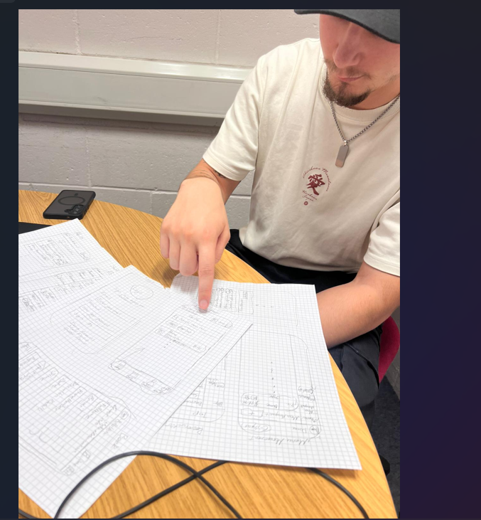

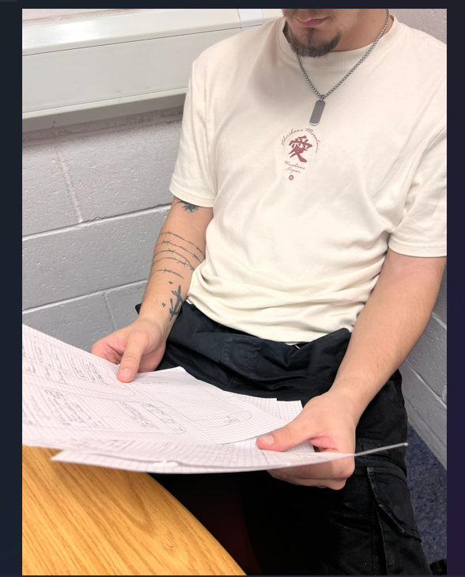

Consent Form

# USER Research Consent Form

Thank you for taking part in our research.

This consent form will help you to understand the purposes of our research. It also outlines how we will use the data that results from your participation.

## Information

### Why we are we doing research?

|  |  |
| --- | --- |
| Who am I? | Okyanus Albas: Comp Sci and Cyber Security Student |
| What are the aims of the research we are doing? | To Find improvement for Low fidelity model and suggestions to improve it |

### Your participation

|  |  |
| --- | --- |
| What research will you be taking part in? | You will be asked to carry out simple tasks using a paper sketch provided by the researcher.  Feedback will be requested following completion of your testing. The test should take around 10 minutes  Your feedback will help catch any design flaws prior to implementation. |
| When will the research take place? | 22-10-2025, 18:00 |
| How will we be capturing your contributions to our research? | Photos will be taken to evidence the study |
| What if you don’t want to take part anymore? | You can withdraw your consent at any point. |

### How we will use this research

|  |  |
| --- | --- |
| What will we use the results of the research for? | Improvements for UI Design and navigation of the app for both users |
| Will we share the results of the research with anyone else? | Yes, the results of the research will be shared with a lecturer |

### Your Data

|  |  |
| --- | --- |
| Where will we store the data captured during the research? | Notes will be taken during the meeting; Photo will be stored on phone. |
| How long will we store the data for? | No longer than 3 months, following 3 months the data will be destroyed |
| How can you ask for your data to be deleted? | Contact me and I will remove all data from any devices |
| How can you ask for a copy of your data? | Contact me |

The personal data you provide will only be used as outlined in this form.

## Declaration

|  |  |
| --- | --- |
| Who to return this form to and how? | Okyanus Albas  Email: albaokya@gmail.com |
| Who to contact if you have any questions about the research? | Researcher: Okyanus Albas  Email: okyanusalbas@students.plymouth.ac.uk |

### Making notes and recordings

Please tick to confirm you agree with each of these.

|  |  |
| --- | --- |
| Do you consent to George Holden using the notes from this session for the purposes of the research outlined above? | Yes |
| Do you consent to George Holden recording the session and using that recording for the purposes of the research outlined above? | Yes |
| Do you consent to George Holden using and sharing anonymised quotes for the purposes of the research outlined above and related publicity of the project? | Yes |
| Do you consent to keeping this research experience private? This means not discussing it in person or in writing including on social media. | Yes |

Declaration

|  |  |
| --- | --- |
| Your name: | Jamie Woodacre |
| Date: | 22/10/2025 |
| Signature: | Jamie Woodacre(X) |

If we have sent this form by email, you do not need to print and sign it.

Instead return the completed form by email with an X in the signature box.

Exercise 4: 15 marks

Neutral Side

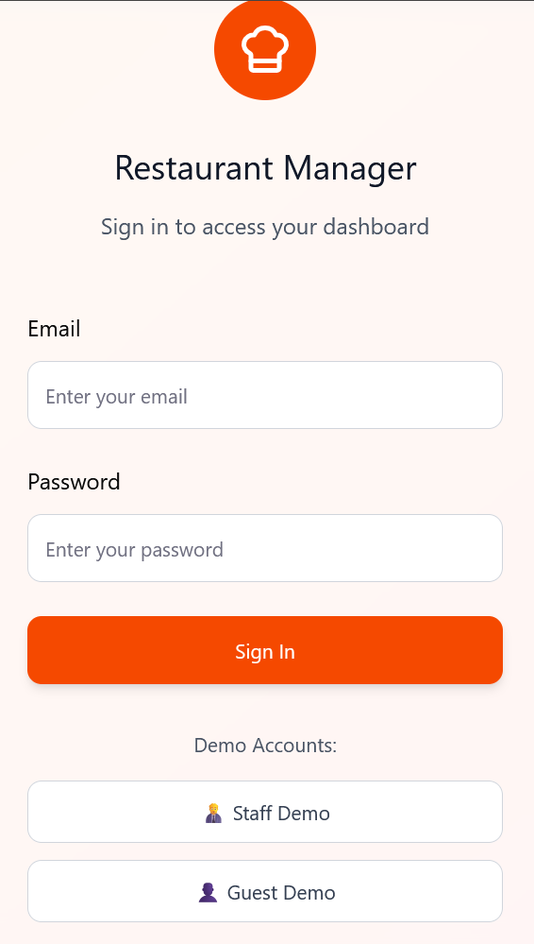

Main Login & Register Pages

Screen: Simple login with email Demo users for now

Option: Role is determined by after login (Staff vs Guest) role-based privileges.

HCI Principle: Visibility of system status show error messages, “loading…” indicators When loading the app or signing in to Guest or Staff Accounts.

Guest Side

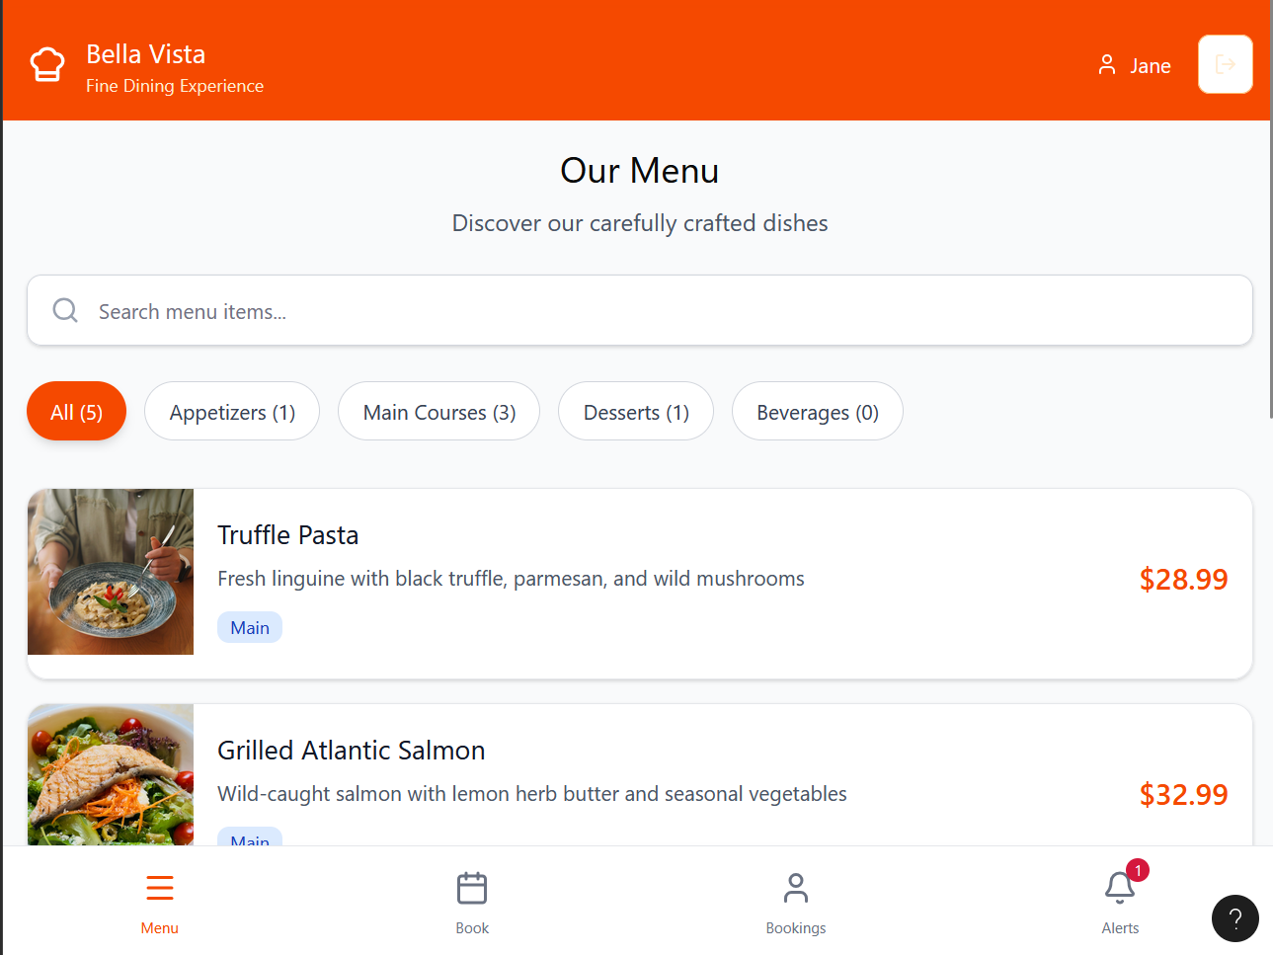

Home/Menu Screen

Top: Restaurant logo, navigation bar.

Middle: Scrollable list of menu items each item has image (thumbnail), name, price.

Bottom: “Make a Book” button. Where you can make reservations

HCI Principle: Recognition over recall (visual images of food, no hidden menus).

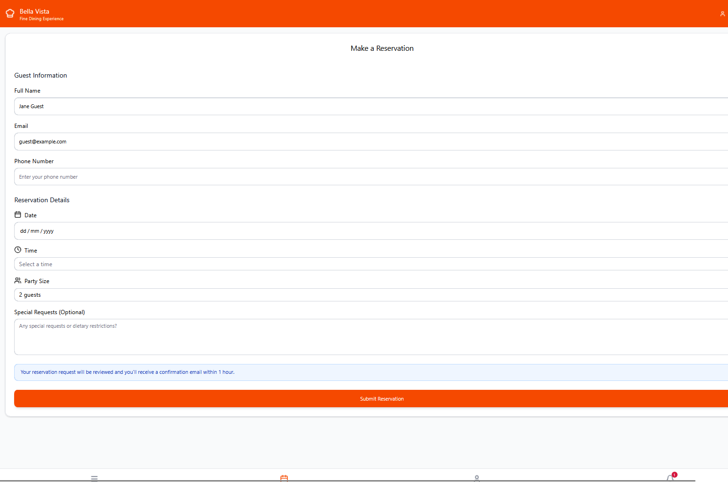

Reservation Form Screen

Input fields: Date picker, Time picker, Number of guests, Notes.

Confirm button.

Feedback: “Reservation Confirmed” pop-up.

HCI Principle: Error prevention (restrict invalid dates/times).

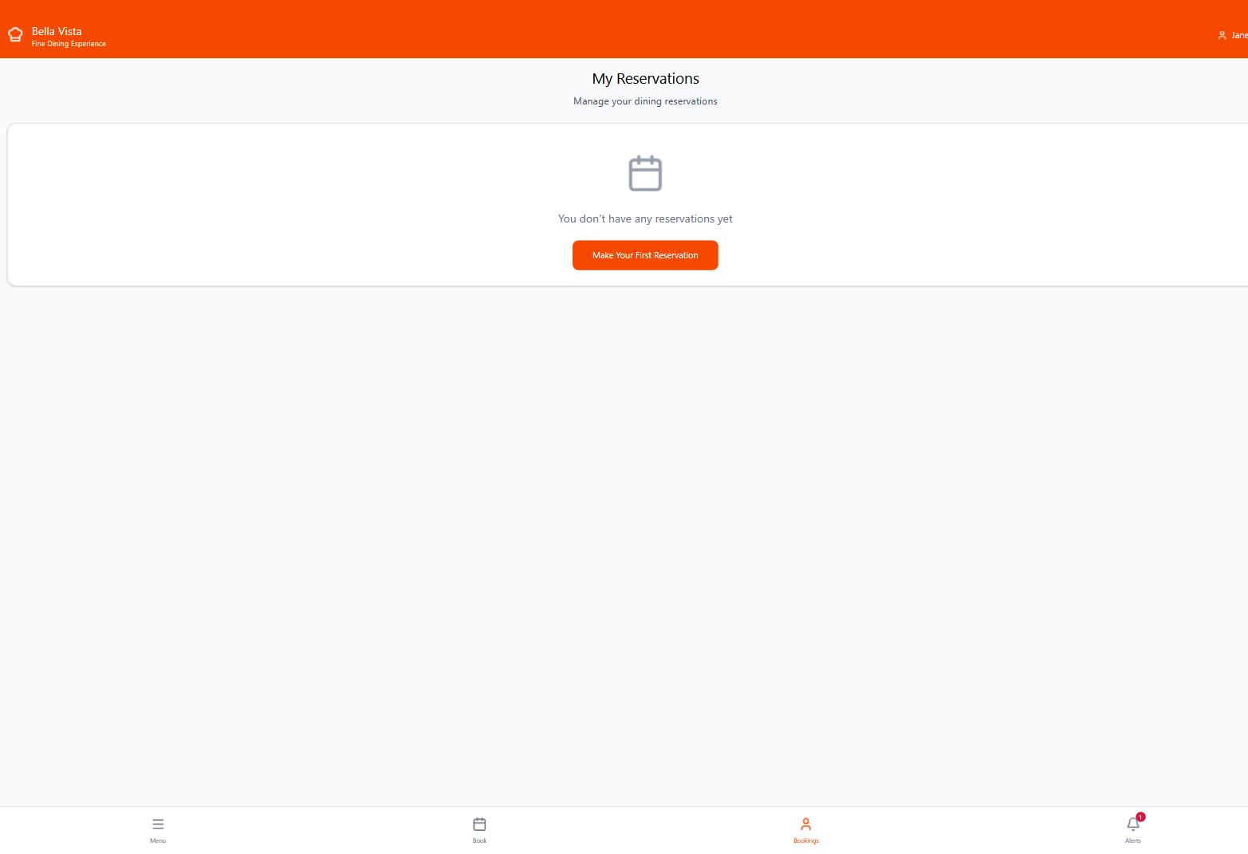

My Reservations Screen

List of upcoming reservations with edit/cancel options.

HCI Principle: User control and freedom (easy cancellation/undo).

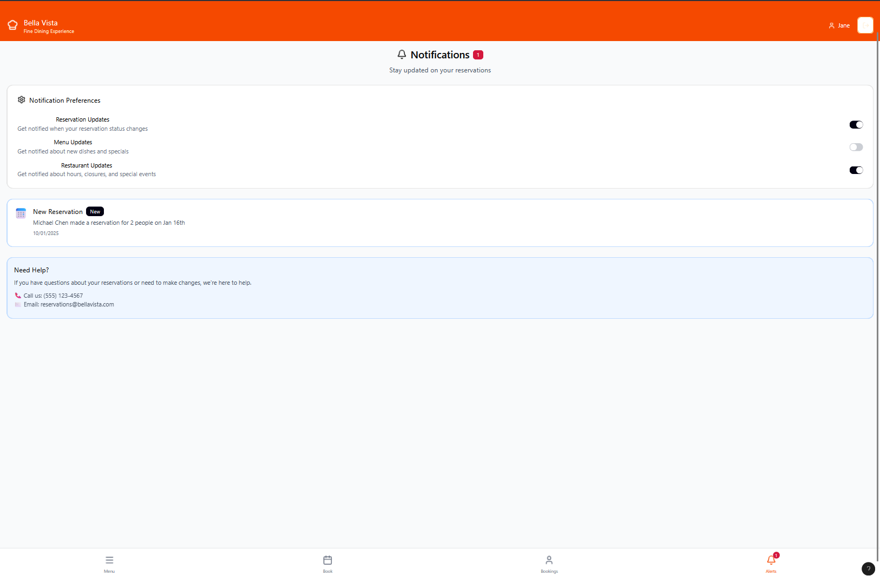

Notification Preferences Screen

Toggles for: Reservation confirmation, Reservation changes, Promotions.

HCI Principle: Flexibility and efficiency.

Staff Side

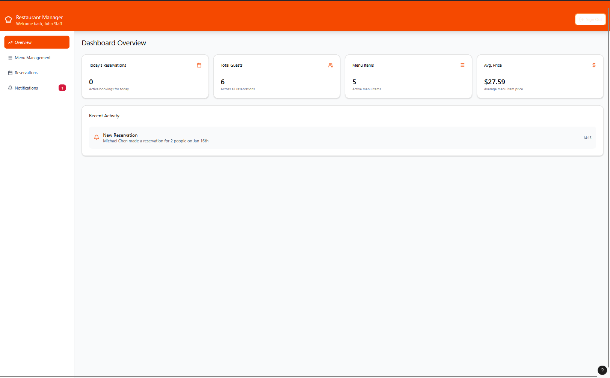

Dashboard Screen

Two buttons: “Menu Management”, “Reservations.”

Notification bell icon shows new reservations.

HCI Principle: Consistency and standards (clear icons).

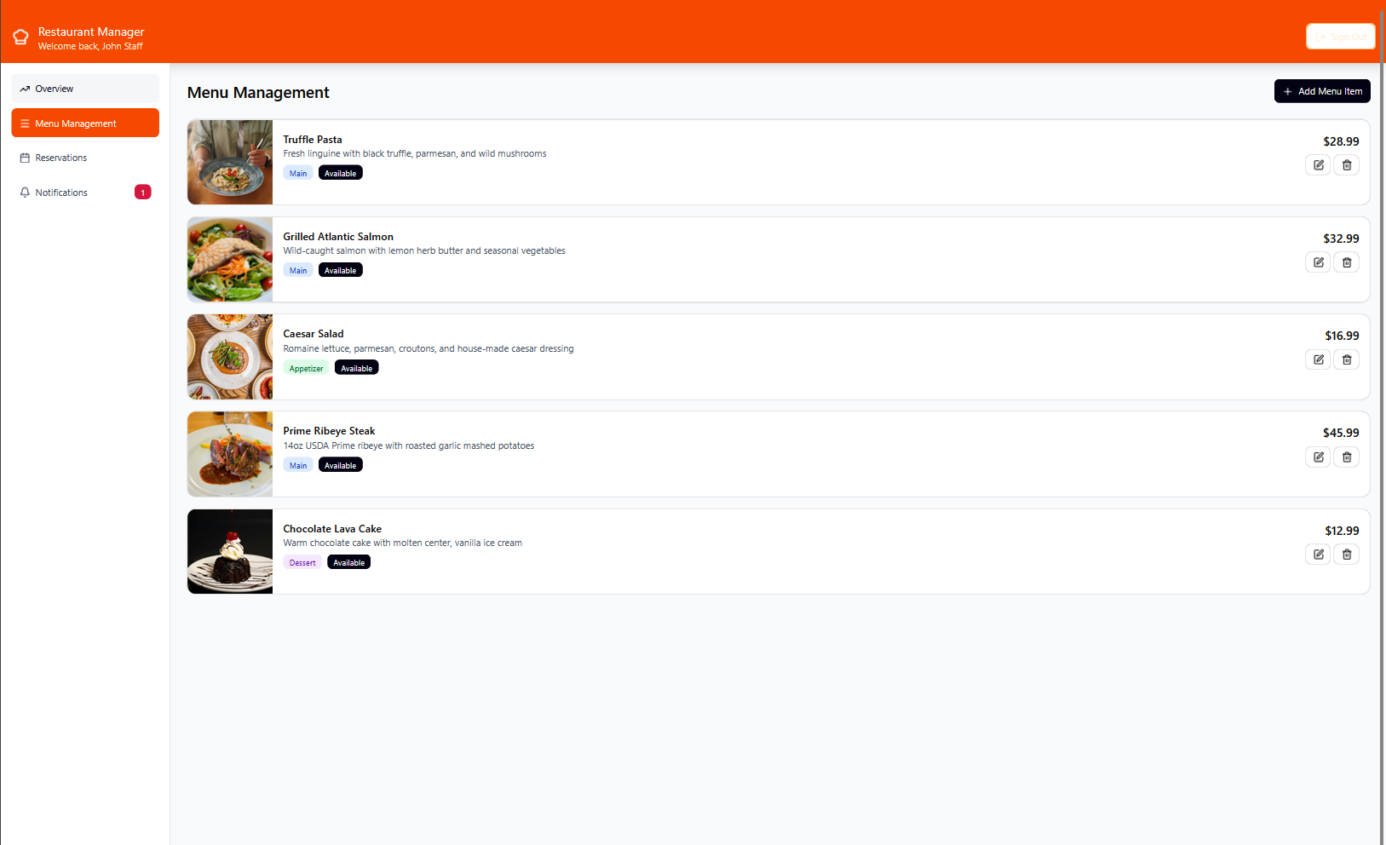

Menu Management Screen

List of current menu items.

Buttons: Add | Edit | Delete (with confirmation prompt).

HCI Principle: Error prevention (confirmation before delete).

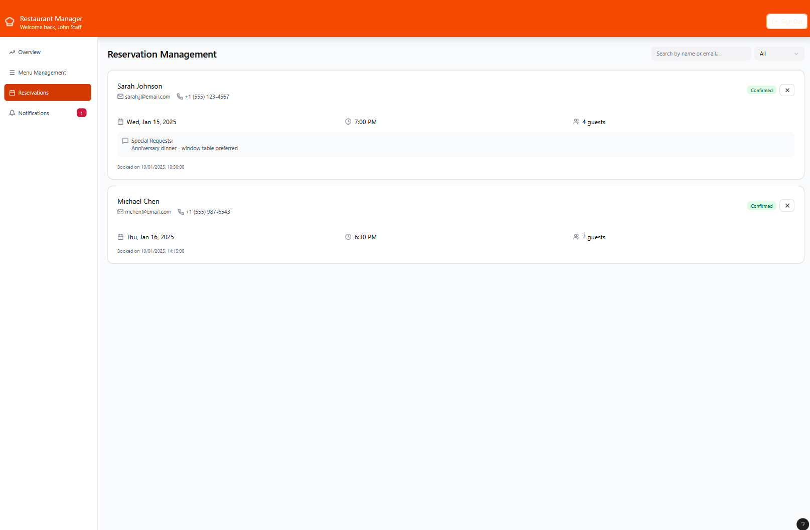

Reservations Screen

List of upcoming reservations with customer name, time, party size.

Options: Cancel reservation, View details.

HCI Principle: Visibility (clear status of each reservation).

Storyboard

|  |  |  |  |
| --- | --- | --- | --- |
| **Role / Goal** | **Step** | **Screen / Action** | **System Response / Visuals** |
| **Staff**  **Manage Menu** | 1 | Staff enters credentials on **branded login screen** (logo, fields, button). | Credentials validated → **Dashboard** with sidebar and top navigation appears. |
|  | 2 | Staff clicks **“Menu Management”** in sidebar. | **Grid layout** of menu items with thumbnails and edit/delete icons shown. |
|  | 3 | Clicks **“Add New Item”** (top-right button). | **Modal form** appears (Name, Price, Upload Image, Description). |
|  | 4 | Fills out fields and clicks **“Save.”** | Success toast (“Item added successfully”). Menu list refreshes dynamically. |
|  | 5 | New reservation occurs. | **Popup banner** appears: “New Reservation – 7:00 PM, 4 Guests.” Notification added to dashboard panel. |
| **Customer**  **Browse Menu** | 1 | Guest opens **mobile app**. | Home screen with restaurant hero image and icons for categories (Starters, Mains, Desserts). |
|  | 2 | Guest taps **“Mains.”** | **Animated transition** to list of menu cards (image, name, price). |
|  | 3 | Guest taps **“Grilled Salmon.”** | **Detail view** shows large photo, full description, and “Add to Favorites / Reserve Now” buttons. |
| **Customer Make/Edit/Cancel Reservation** | 1 | Guest selects **“Reserve a Table.”** | Stylish **form UI** with date picker, time selector, guest dropdown, and notes field. |
|  | 2 | Guest confirms reservation. | Loading spinner → **Confirmation screen** with booking summary and “Add to Calendar” option. |
|  | 3 | Staff dashboard updates. | **Notification card** appears with guest name and reservation details. |
|  | 4 | Guest opens **“My Reservations.”** | Modern list view with colored status tags (Confirmed, Pending, Cancelled). |
|  | 5 | Guest edits or cancels booking. | System updates instantly, shows **success toast**, and syncs staff dashboard. |
|  | 6 | Staff changes reservation status. | Guest receives **push notification:** “Your reservation has been confirmed!” |

Set Exercise 5: 30 marks

Login

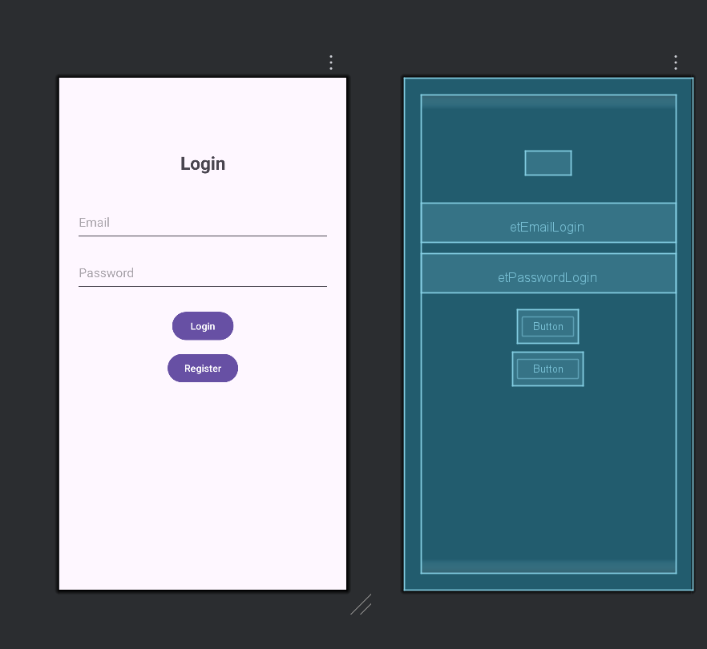

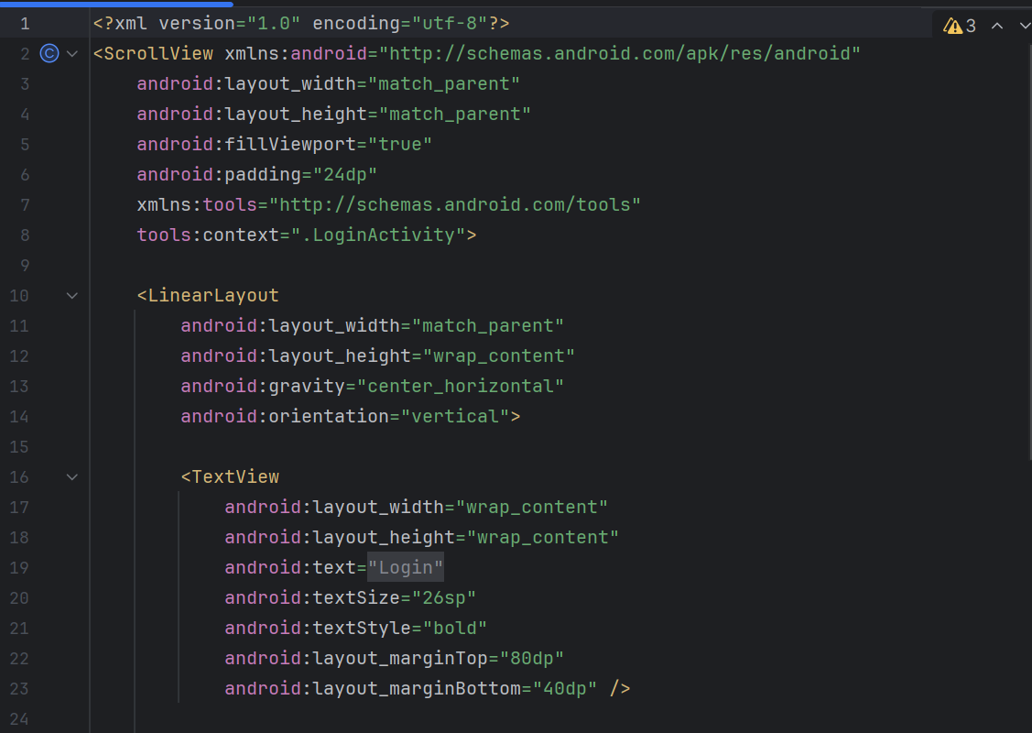

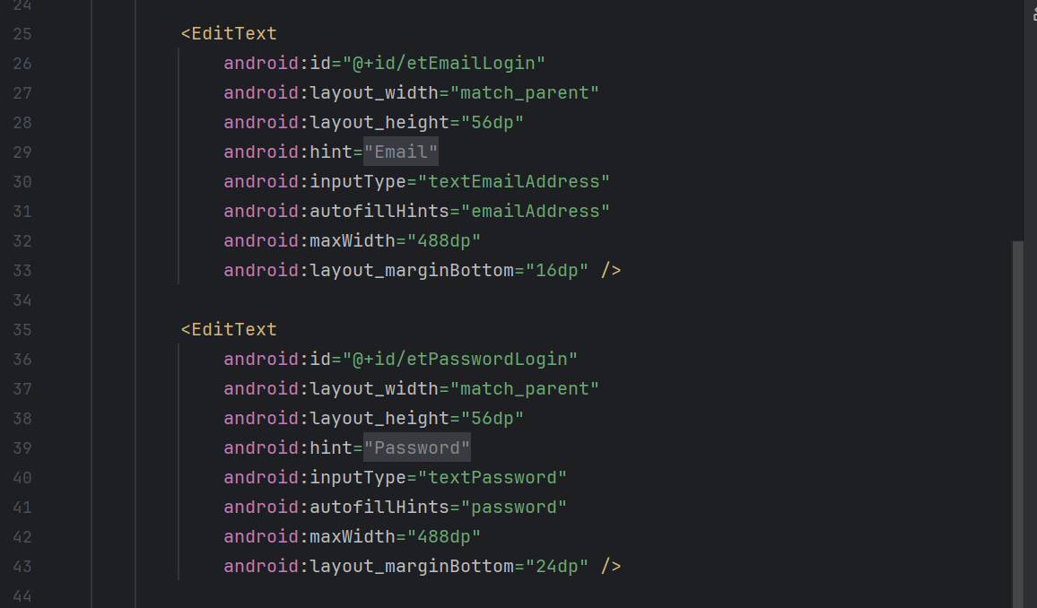

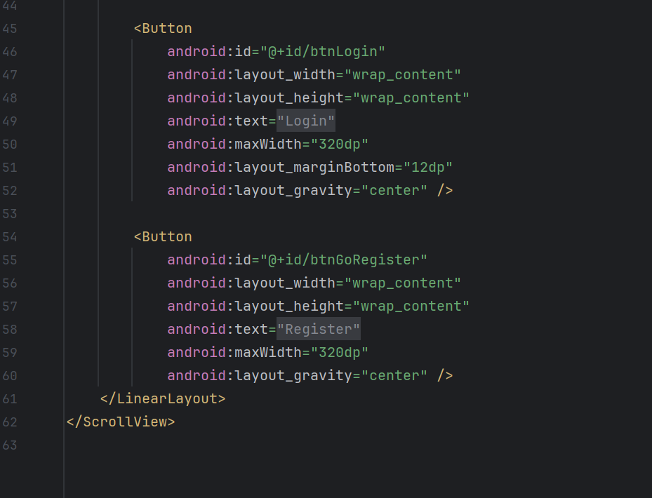

Register

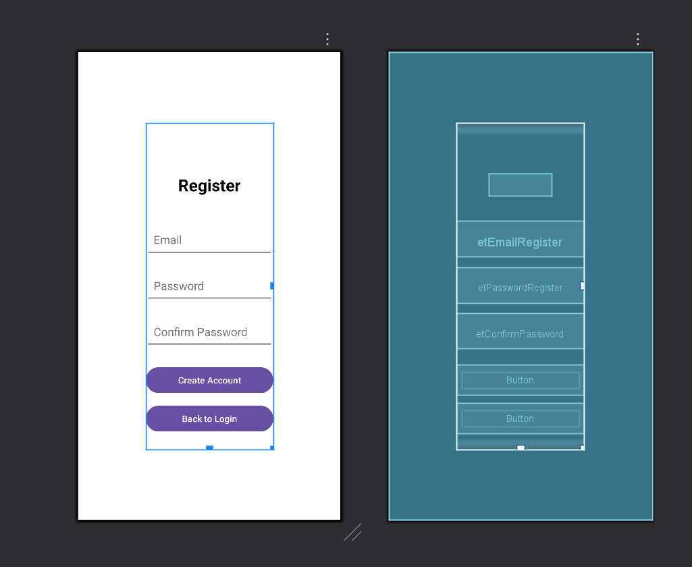

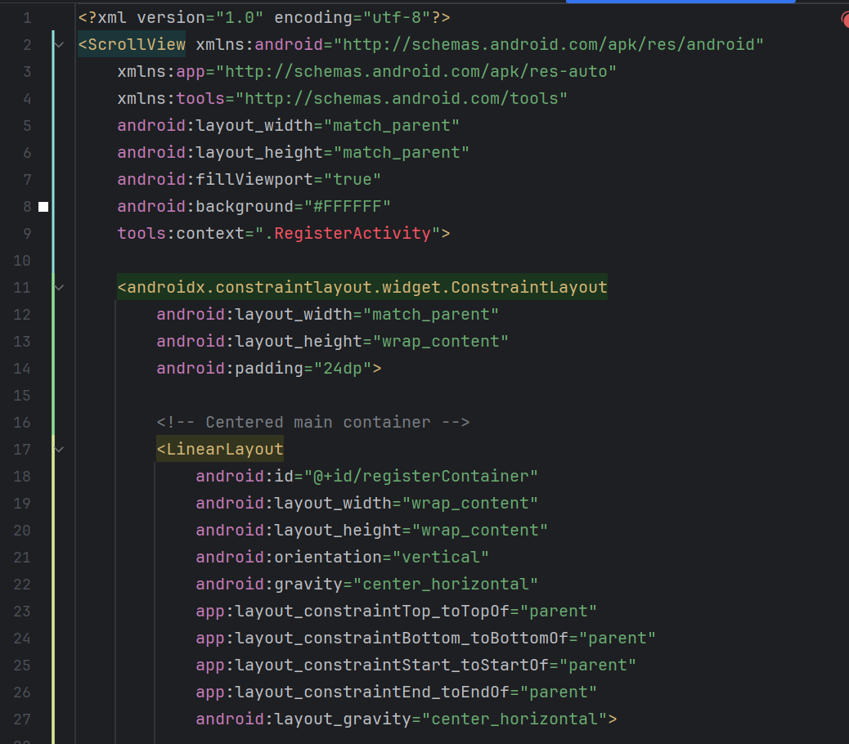

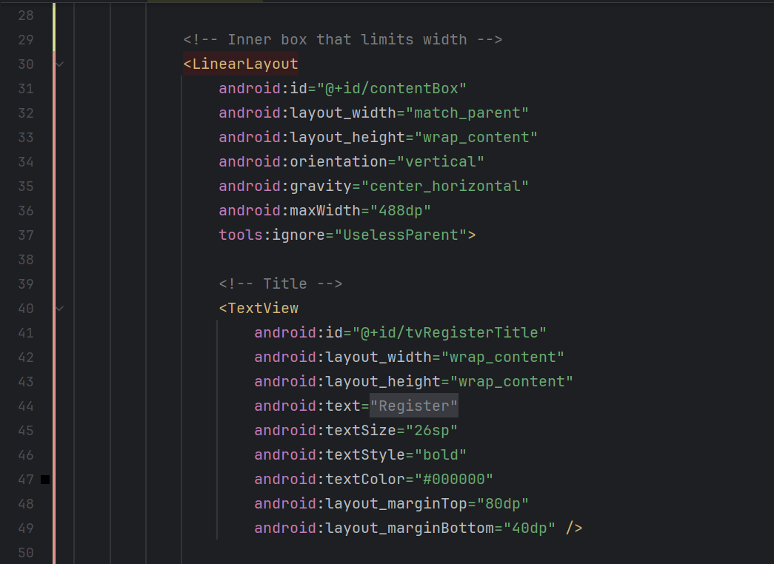

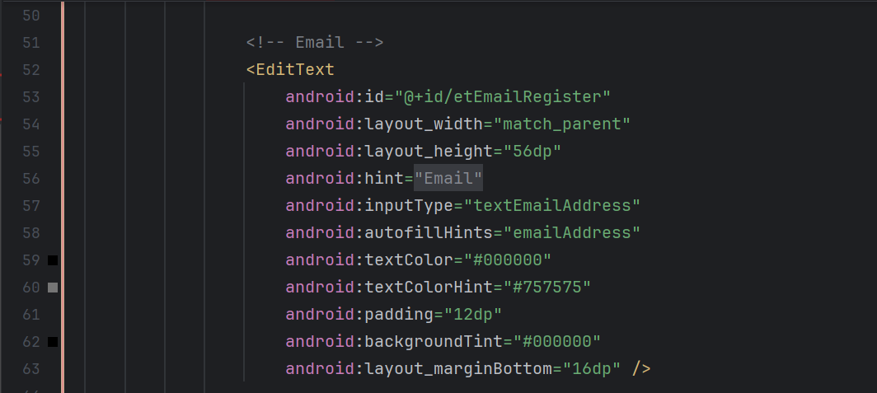

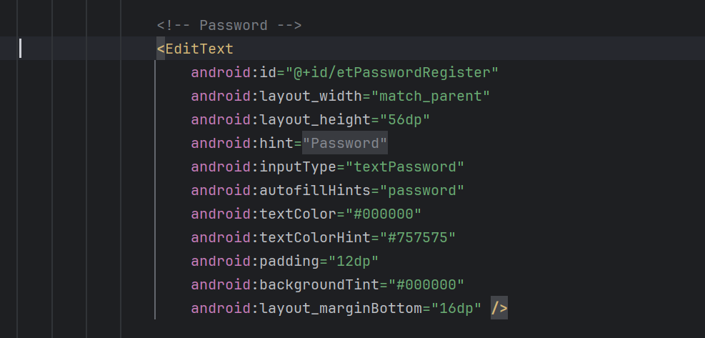

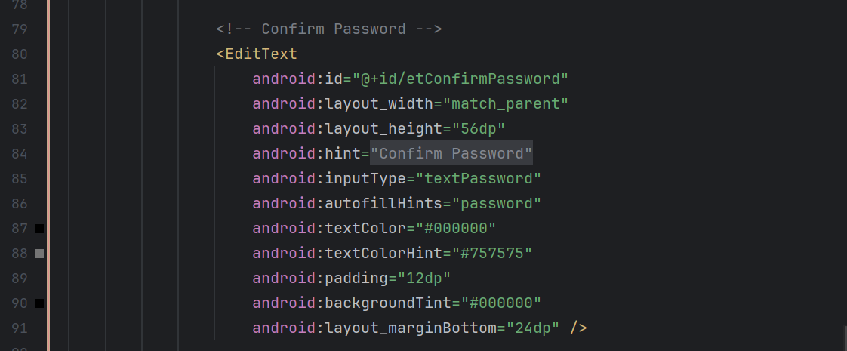

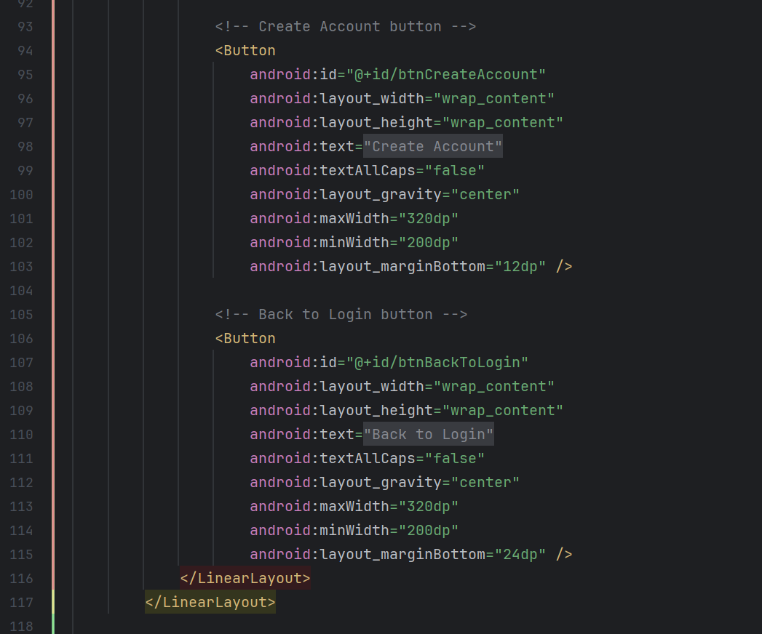

Home/Menu Screen

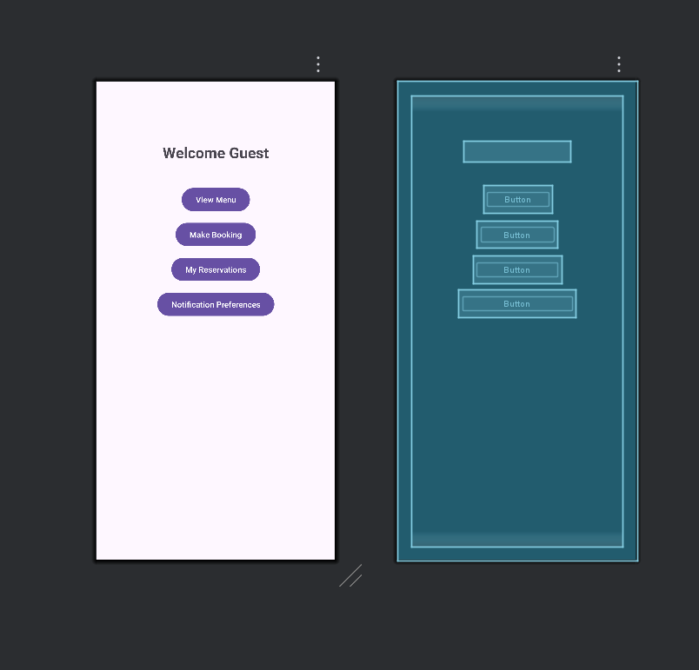

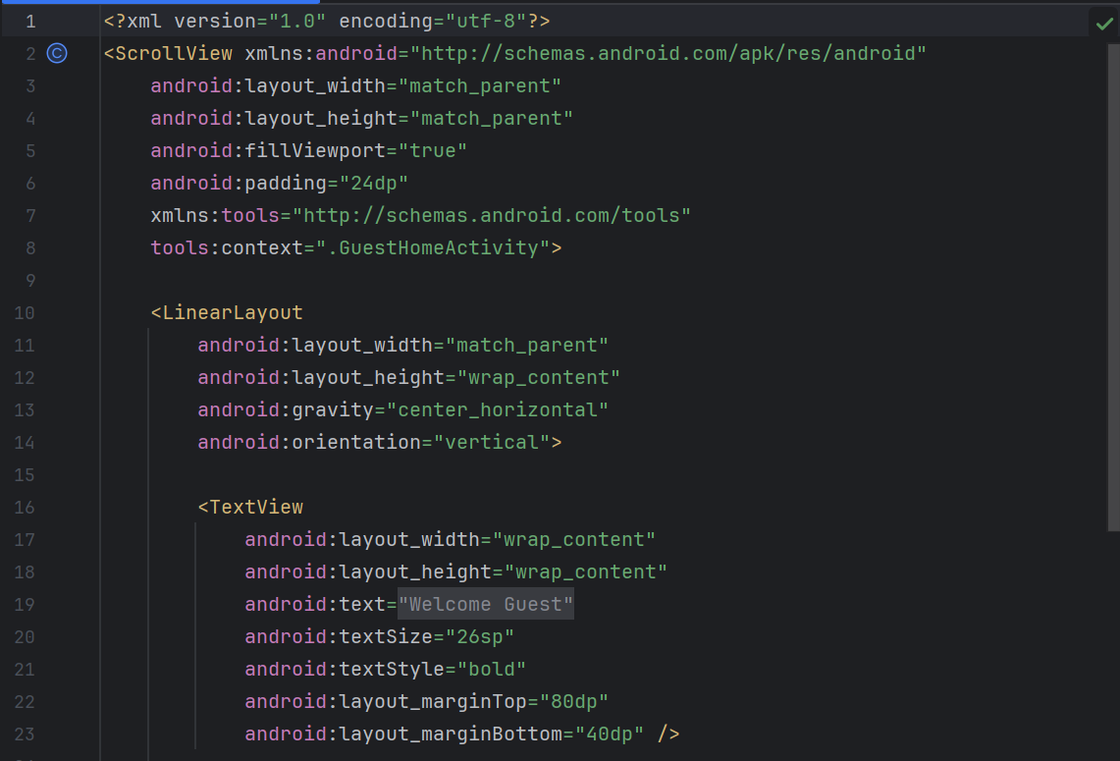

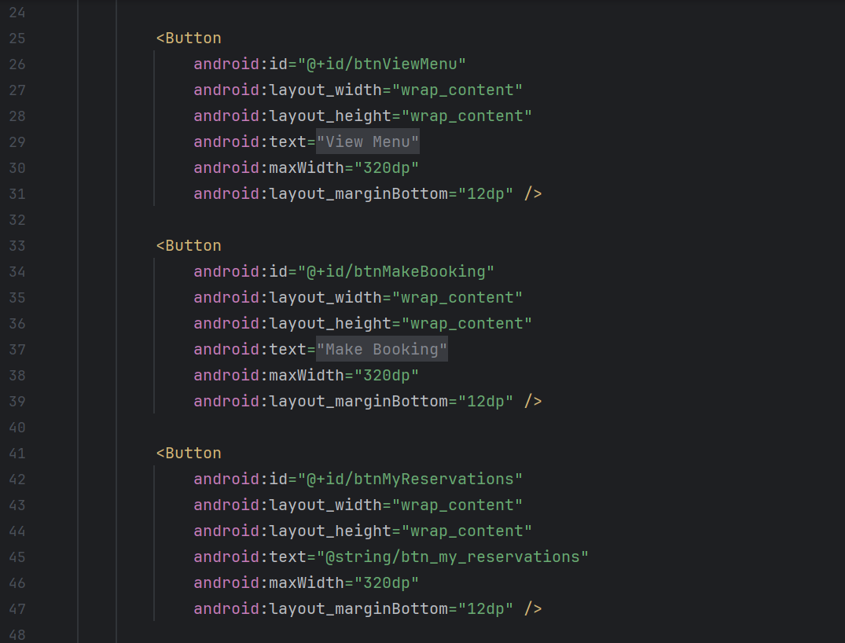

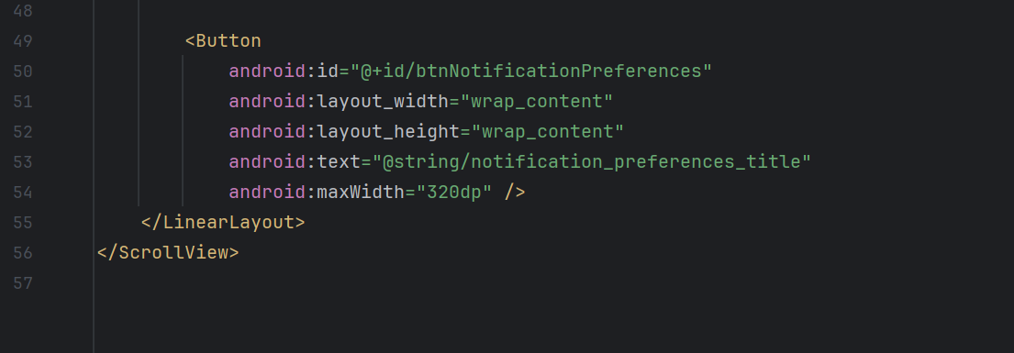

Reservation Form Screen

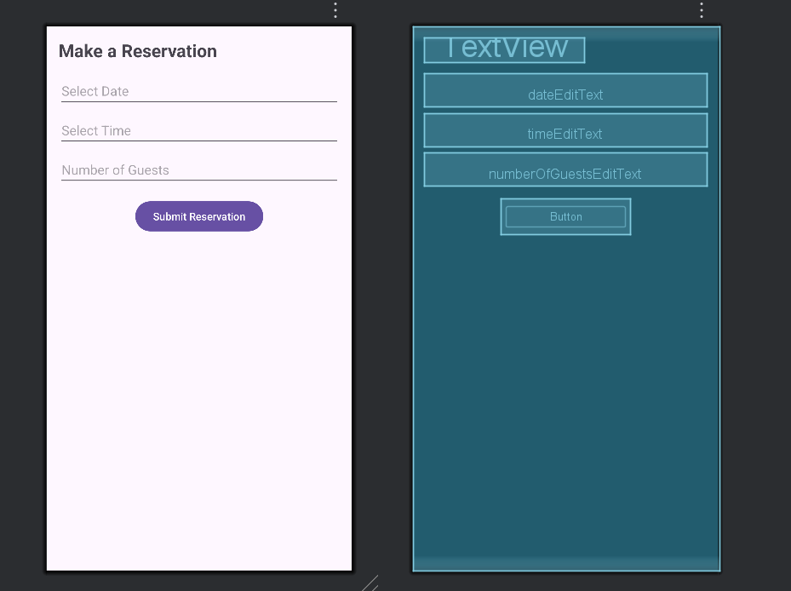

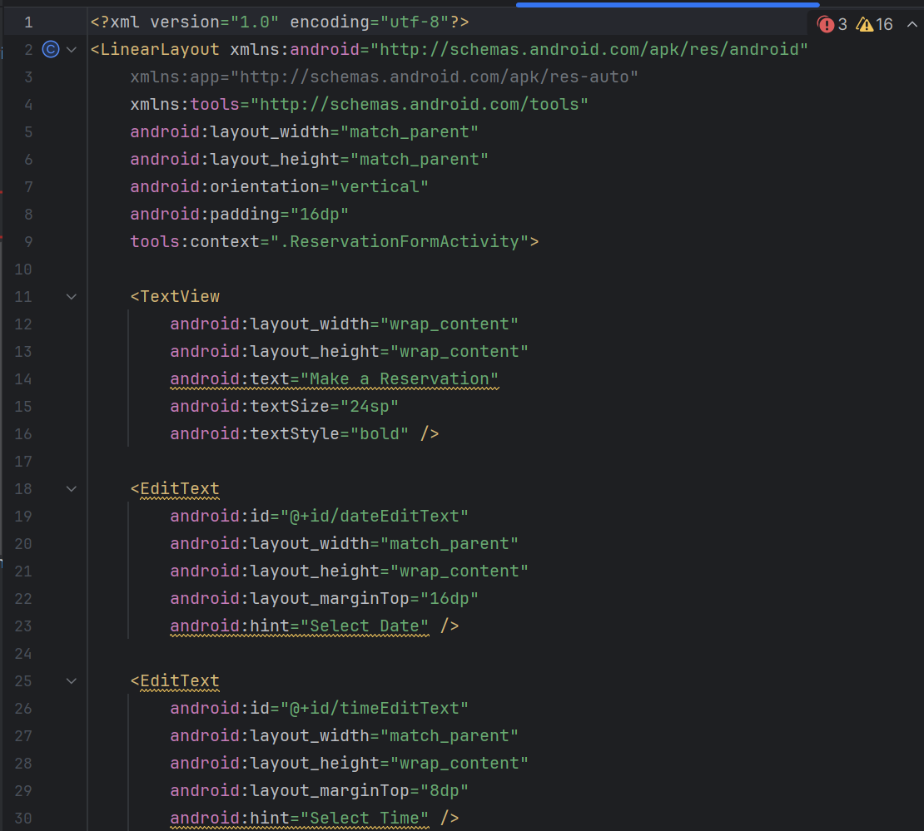

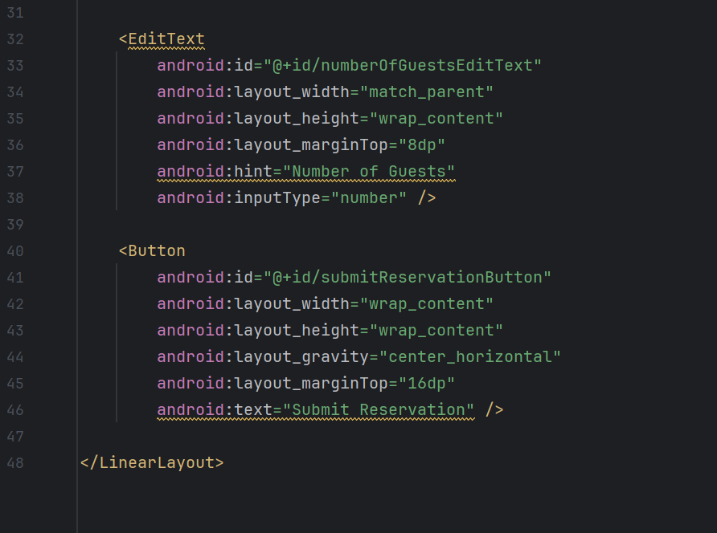

My Reservations Screen

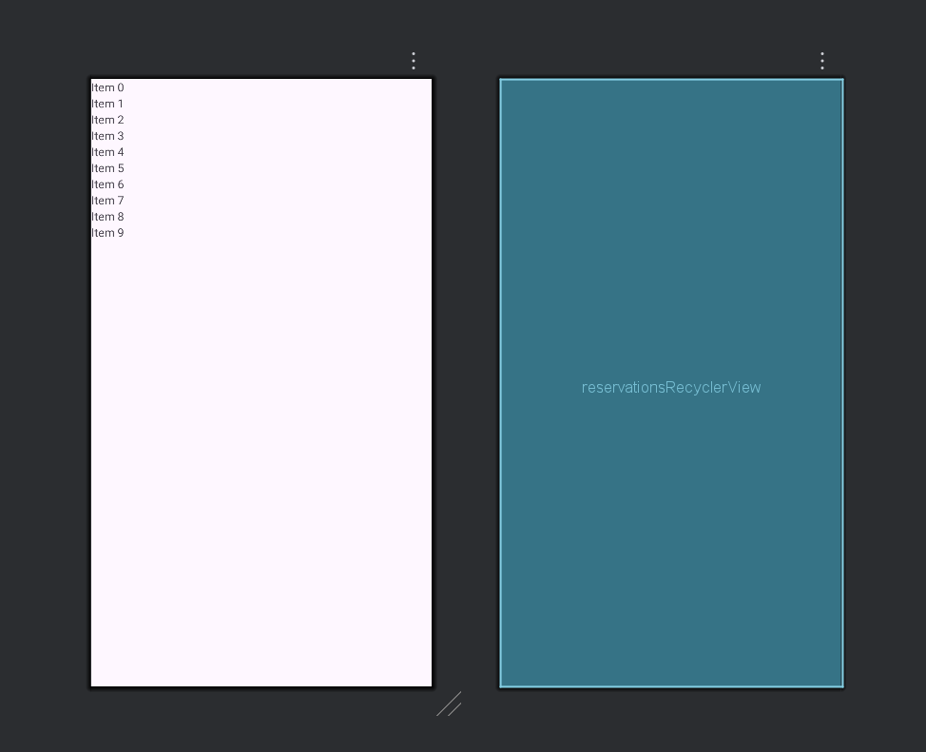

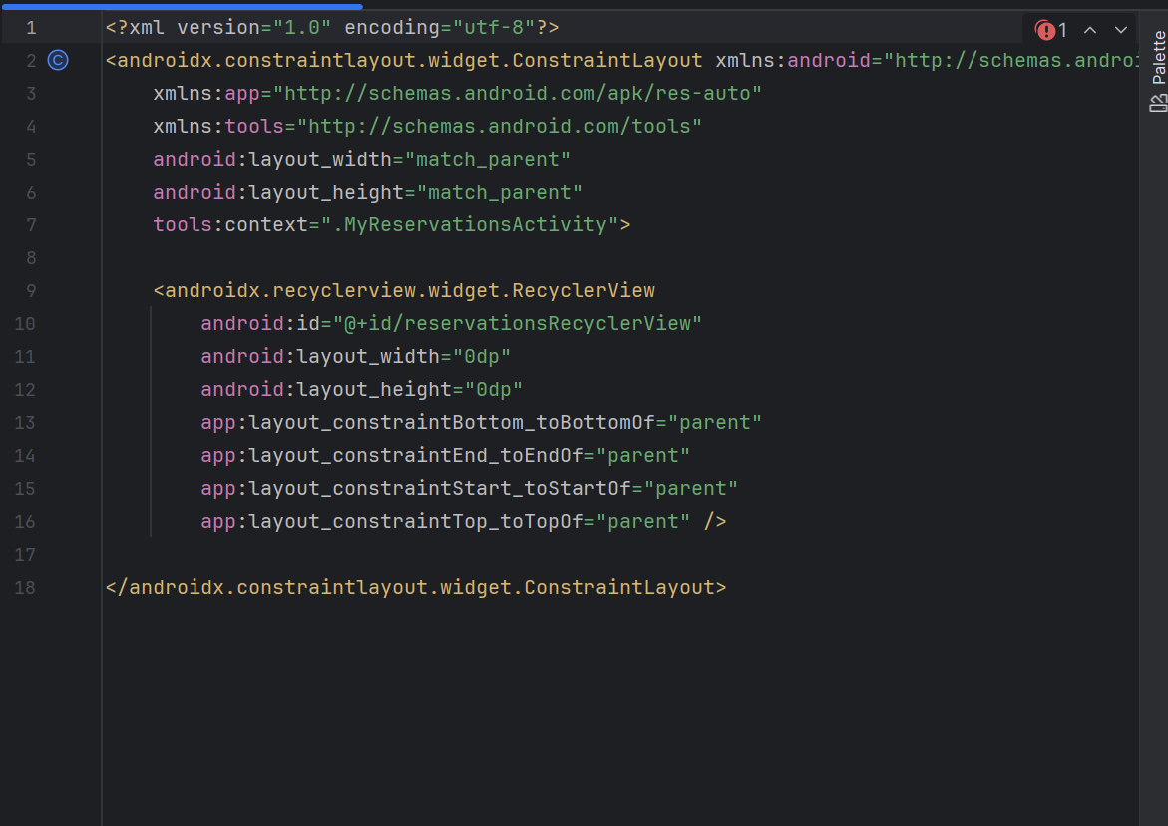

Notification Preferences Screen

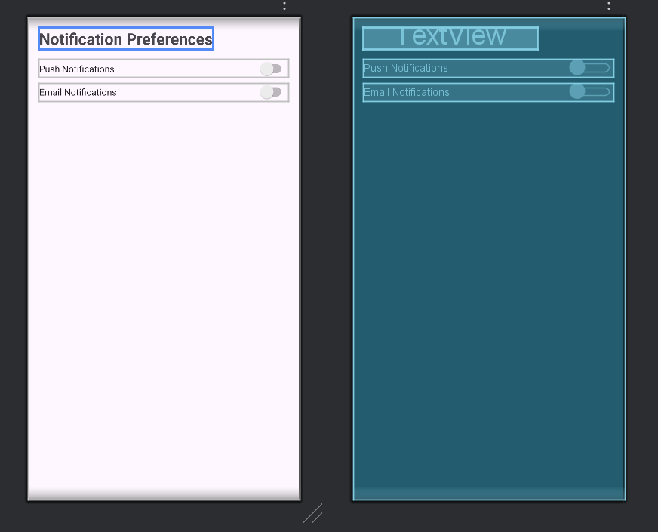

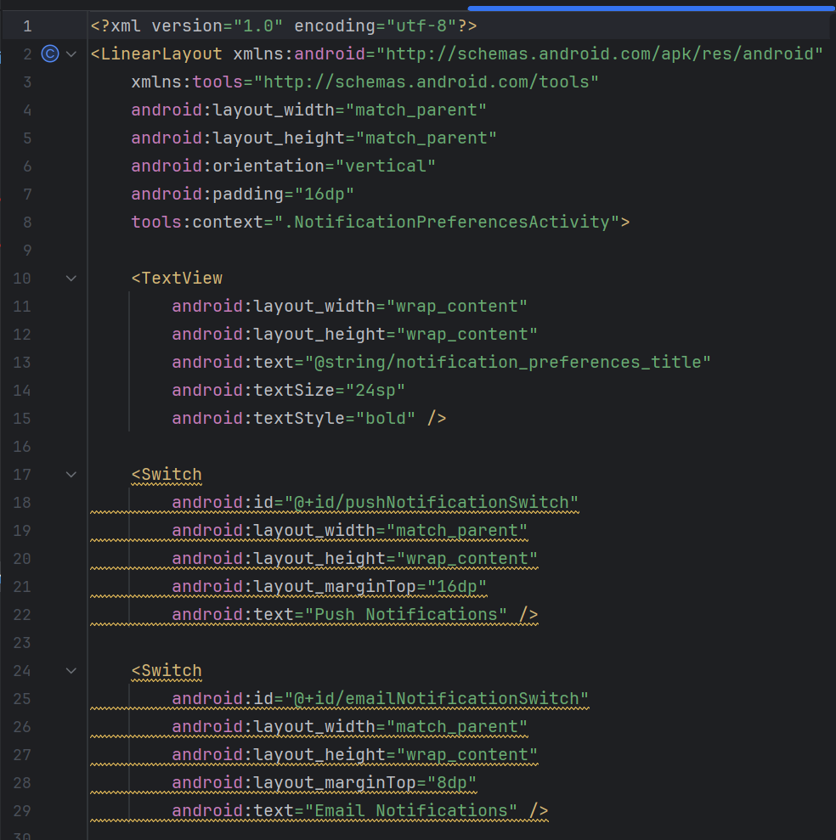



Student Declaration of AI Tool use in this Assessment

Please indicate your level of usage of generative AI for this assessment - please tick the appropriate category(s).

If the “Assisted Work” or “Partnered Work” category is selected, please expand on the usage and in which elements of the assignment the usage refers to.

|  |  |  |
| --- | --- | --- |
| Solo Work | S1 - Generative AI tools have not been used for this assessment. |  |
| Assisted Work | A1 – Idea Generation and Problem Exploration  Used to generate project ideas, explore different approaches to solving a problem, or suggest features for software or systems. Students must critically assess AI-generated suggestions and ensure their own intellectual contributions are central. |  |
| A2 - Planning & Structuring Projects AI may help outline the structure of reports, documentation and projects. The final structure and implementation must be the student’s own work. |  |
| A3 – Code Architecture  AI tools maybe used to help outline code architecture (e.g. suggesting class hierarchies or module breakdowns). The final code structure must be the student’s own work. |  |
| A4 – Research Assistance  Used to locate and summarise relevant articles, academic papers, technical documentation, or online resources (e.g. Stack Overflow, GitHub discussions. The interpretation and integration of research into the assignment remain the student’s responsibility. |  |
| A5 - Language Refinement Used to check grammar, refine language, improve sentence structure in documentation not code. AI should be used only to provide suggestions for improvement. Students must ensure that the documentation accurately reflects the code and is technically correct. |  |
| A6 – Code Review  AI tools can be used to check comments within the code and to suggest improvements to code readability, structure or syntax. AI should be used only to provide suggestions for improvement. Students must ensure that the code accurately reflects their knowledge and is technically correct. |  |
| A7 - Code Generation for Learning Purposes Used to generate example code snippets to understand syntax, explore alternative implementations, or learn new programming paradigms. Students must not submit AI-generated code as their own and must be able to explain how it works. |  |
| A8 - Technical Guidance & Debugging Support AI tools can be used to explain algorithms, programming concepts, or debugging strategies. Students may also help interpret error messages or suggest possible fixes. However, students must write, test, and debug their own code independently and understand all solutions submitted. |  |
| A9 - Testing and Validation Support AI may assist in generating test cases, validating outputs, or suggesting edge cases for software testing. Students are responsible for designing comprehensive test plans and interpreting test results. |  |
| A10 - Data Analysis and Visualization Guidance AI tools can help suggest ways to analyse datasets or visualize results (e.g. recommending chart types or statistical methods). Students must perform the analysis themselves and understand the implications of the results. |  |
| A11 - Other uses not listed above  Please specify: |  |
| Partnered Work | P1 - Generative AI tool usage has been used integrally for this assessment  Students can adopt approaches that are compliant with instructions in the assessment brief.  Please Specify: |  |

|  |
| --- |
| Please provide details of AI usage and which elements of the coursework this relates to: |

|  |  |
| --- | --- |
| I understand that the ownership and responsibility for the academic integrity of this submitted assessment falls with me, the student. |  |
| I confirm that all details provide above are an accurate description of how AI was used for this assessment. |  |